PYTHON PROGRAMMING
PYTHON ASSIGNMENT
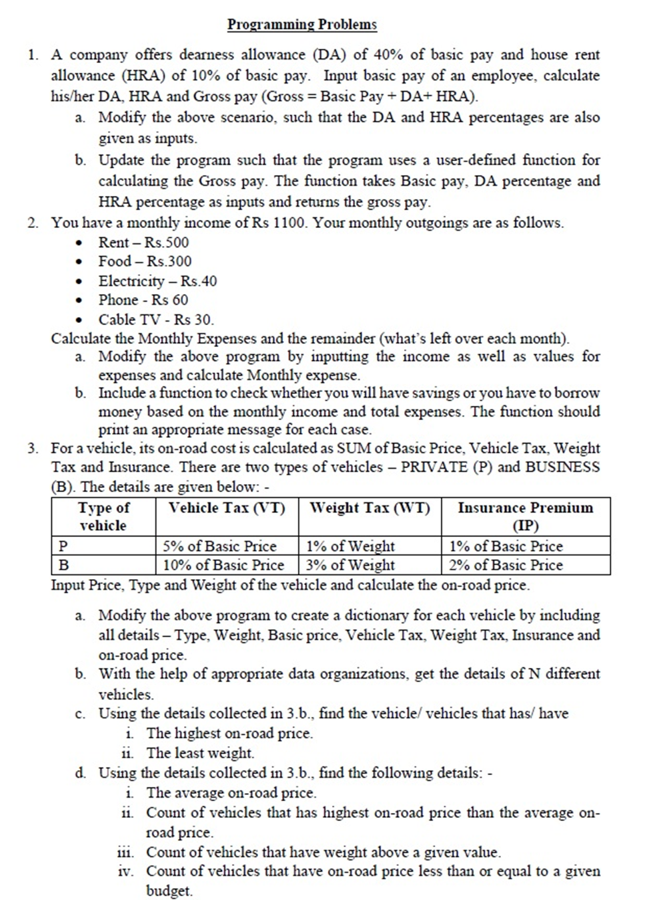

Python Programming Answer: -

1. Salary Calculation (DA, HRA, Gross Pay)
1(a) Basic Program – DA=40%, HRA=10%
basic_pay = float(input("Enter Basic Pay: "))

DA = 0.40 * basic_pay
HRA = 0.10 * basic_pay
gross_pay = basic_pay + DA + HRA

print("DA:", DA)
print("HRA:", HRA)
print("Gross Pay:", gross_pay)

1(b) Modify to accept DA% and HRA% as inputs
basic_pay = float(input("Enter Basic Pay: "))
da_percent = float(input("Enter DA percentage: "))
hra_percent = float(input("Enter HRA percentage: "))

DA = (da_percent / 100) * basic_pay
HRA = (hra_percent / 100) * basic_pay
gross_pay = basic_pay + DA + HRA

print("DA:", DA)
print("HRA:", HRA)
print("Gross Pay:", gross_pay)

1(c) Use a user-defined function
def calculate_gross(basic, da_percent, hra_percent):
DA = (da_percent / 100) * basic
HRA = (hra_percent / 100) * basic
return basic + DA + HRA

basic_pay = float(input("Enter Basic Pay: "))
da_percent = float(input("Enter DA percentage: "))
hra_percent = float(input("Enter HRA percentage: "))

gross = calculate_gross(basic_pay, da_percent, hra_percent)
print("Gross Pay:", gross)

2. Monthly Income & Expenses
2(a) Basic Program – fixed values
income = 1100
rent = 500
food = 300
electricity = 40
phone = 60
cable = 30

total_expense = rent + food + electricity + phone + cable
remaining = income - total_expense

print("Total Monthly Expense:", total_expense)
print("Remaining:", remaining)

2(b) Input income & expenses
income = float(input("Enter Monthly Income: "))
rent = float(input("Enter Rent: "))
food = float(input("Enter Food Expense: "))
electricity = float(input("Enter Electricity Bill: "))
phone = float(input("Enter Phone Bill: "))
cable = float(input("Enter Cable TV Bill: "))

total_expense = rent + food + electricity + phone + cable
remaining = income - total_expense

print("Total Monthly Expense:", total_expense)
print("Remaining:", remaining)

2(c) Add a function to check savings or borrow
def check_status(income, expenses):
if income > expenses:
print("You have savings this month.")
else:
print("You need to borrow money this month.")

income = float(input("Enter Monthly Income: "))
expenses = float(input("Enter Total Monthly Expenses: "))

check_status(income, expenses)

3. Vehicle On-Road Price Calculation
Given Conditions
Type | Vehicle Tax | Weight Tax | Insurance
P | 5% of basic price | 1% of weight | 1% of basic price
B | 10% of basic price | 3% of weight | 2% of basic price

3(a) Compute on-road price & store details in a dictionary
vehicle_type = input("Enter Vehicle Type (P/B): ").upper()
basic_price = float(input("Enter Basic Price: "))
weight = float(input("Enter Weight: "))

if vehicle_type == "P":
VT = 0.05 * basic_price
WT = 0.01 * weight
IP = 0.01 * basic_price
elif vehicle_type == "B":
VT = 0.10 * basic_price
WT = 0.03 * weight
IP = 0.02 * basic_price

onroad_price = basic_price + VT + WT + IP

vehicle = {
"Type": vehicle_type,
"Weight": weight,
"Basic Price": basic_price,
"Vehicle Tax": VT,
"Weight Tax": WT,
"Insurance": IP,
"On-road Price": onroad_price
}

print(vehicle)

3(b) Get details of N vehicles
vehicles = []
N = int(input("Enter number of vehicles: "))

for i in range(N):
print(f"\n--- Vehicle {i+1} ---")
vtype = input("Enter Vehicle Type (P/B): ").upper()
price = float(input("Enter Basic Price: "))
weight = float(input("Enter Weight: "))

if vtype == "P":
VT = 0.05 * price
WT = 0.01 * weight
IP = 0.01 * price
else:
VT = 0.10 * price
WT = 0.03 * weight
IP = 0.02 * price

onroad = price + VT + WT + IP

vehicle = {
"Type": vtype,
"Weight": weight,
"Basic Price": price,
"Vehicle Tax": VT,
"Weight Tax": WT,
"Insurance": IP,
"On-road Price": onroad
}
vehicles.append(vehicle)

3(c) Find:
i. Vehicle(s) with highest on-road price
max_price = max(v["On-road Price"] for v in vehicles)
print("\nVehicles with Highest On-road Price:")
for v in vehicles:
if v["On-road Price"] == max_price:
print(v)
ii. Vehicle(s) with least weight
min_weight = min(v["Weight"] for v in vehicles)
print("\nVehicles with Least Weight:")
for v in vehicles:
if v["Weight"] == min_weight:
print(v)

3(d) Additional Calculations
i. Average on-road price
avg_price = sum(v["On-road Price"] for v in vehicles) / len(vehicles)
print("\nAverage On-road Price:", avg_price)
ii. Count of vehicles priced above average
count_above_avg = sum(1 for v in vehicles if v["On-road Price"] > avg_price)
print("Vehicles priced above average:", count_above_avg)
iii. Count of vehicles with weight above given value
limit_weight = float(input("Enter weight limit: "))
count_above_weight = sum(1 for v in vehicles if v["Weight"] > limit_weight)
print("Vehicles above given weight:", count_above_weight)
iv. Count of vehicles within a given budget
budget = float(input("Enter budget: "))
count_within_budget = sum(1 for v in vehicles if v["On-road Price"] <= budget)
print("Vehicles within budget:", count_within_budget)

